
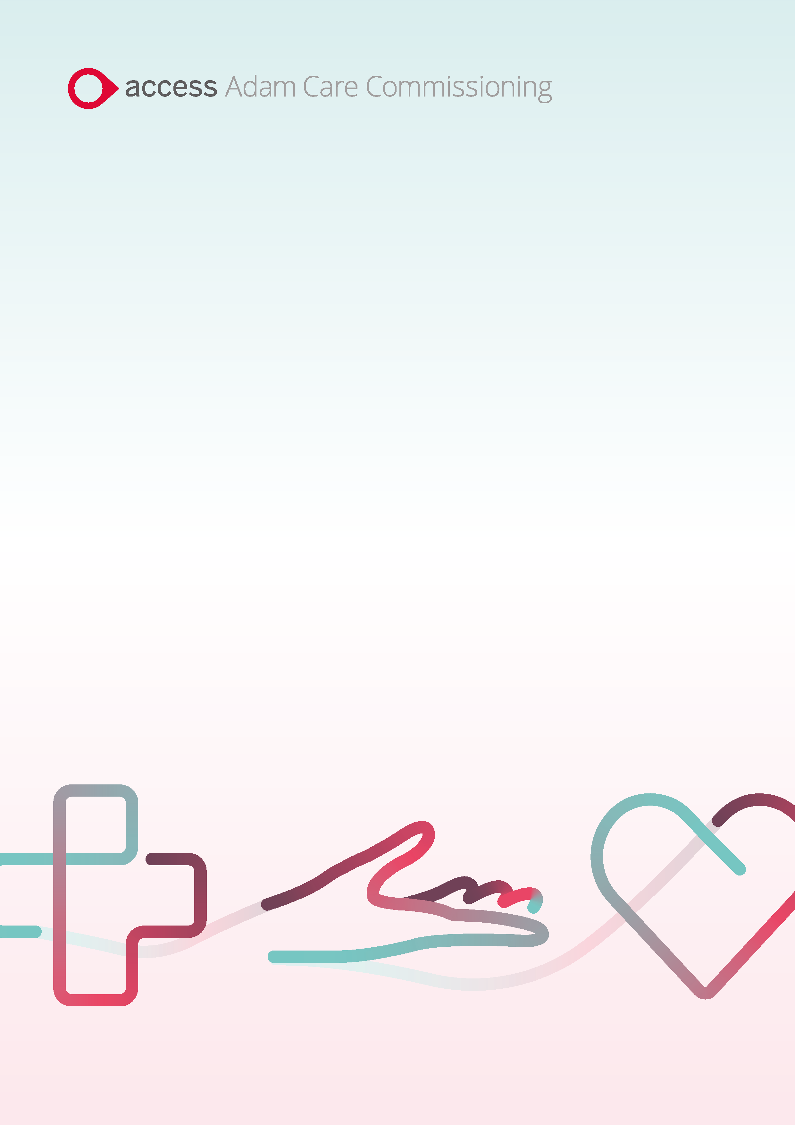

FAQ Document

Passenger Transport Services
Bradford Metropolitan District Council

Date February 2025

Question No. | Question | Answer
1 | what do you need to put in where it states legal entity type? | This will depend on your company, there will be a drop down within the registration form on which one is relevant to yourselves.
2 | When uploading documents and expiry dates, if your documents expire are you then blocked out of bidding for a contract until you upload a new document and change valid/expiry date? | There are notifications that will come through automatically from the system to make you aware of if your Accreditation or Enrolment documents are due to expire, allowing you to update and stay valid.
3 | Is the billing and invoicing within the system?  Therefore no need for self-invoicing? | These discussions are ongoing.
4 | If we are invoicing weekly are we getting paid weekly or do we have the option to get paid monthly? | All invoices will remain monthly.
5 | Can you add in advance dates on insurance documents? | Issue date is likely to be present/past, with the expiry date in the future. There is the option to add the relevant dates to these fields where needed.
6 | Will the system choose the bidder automatically or will there be someone overlooking the bids? | This is not an automatic process, there will be a team member(s) within Bradford Council that will be deciding on the winning bidder.
10 | Will the winning bidder be made public? | You would not be able to see the winning bid price within the system.  This is an open tender process so you will be able to see the winning bidder for each contracted route.
11 | Will we still receive notification on the winning bids? | All suppliers will be notified of the winning bid.
12 | Do we need to upload the invoices on here? | There will be no need to upload invoices to the system, if finances are going to be used through the system details on how to complete this will be gone through in detail in our later training sessions.
13 | Has this system been trialled with any operators? | There is not a trial period open to operators at the moment. A lot of work is going into the system from Bradford Council and the Access adam team to ensure the system will work for providers and the council. If you do have any queries around this though please feel free to reach out during this period. In terms of the bidding it is still currently being built so not available at the moment, if available we will let you know.
14 | If it's going live in 6weeks time when will we be getting invites to join and set up? | The invites to join the system will be sent out on the 19/2/2025 via email comms.
15 | Is there more transparency of who holds the contracts? | These processes are remaining the same as they currently stand.
16 | Currently we can do an FOI for all tenders. Will all tenders be visible historically also and if so how long a period? | Within the system you will be able to see all your past information.  The FOI process will remain the same, providers will need to go through the corporate system as it stands now.
17 | What about the escort training will that be shown on the system when it becomes available. | Escort training will not be a part of the SProc process.
18 | Every authority works differently. How can adams be sure this the correct system for Bradford council or trade. | We will be building the system specifically for the processes within Bradford and best to accommodate for their providers.
19 | Are we having to go into the system to check if we have won a bid or will we get separate emails confirming? | You will receive system generated emails that will be sent out to keep up to date with your notifications, you will then be able to see further details when you log into the system.
20 | So whats the next step from this meeting? | You will need to register your company to SProc and then complete the Accreditation and Enrolment for Bradford Metropolitan District Council – for the Passenger Transport Services
21 | What is adam support timing/ days, hours holiday period | Once the system is live there will be the support team available via phone, live chat and email between 8.30-5.00 Monday – Friday. We will not be available on bank holidays.
22 | If I want to become a multi-fleet do I tell adam or bradford council? | You would need to contact Bradford Council directly on pts.suppliers@bradford.gov.uk
23 | Will you email confirming if there is new contracts to bid on or do we still need to go into system to check? | You will receive the system generated email notifications for available requirements that you can bid on. You would then need to log into the system to see further details.
24 | The school runs that have been awarded will they be re-tendered or will they carry on as normal? | If you currently have a contract with Bradford that will stay the same. As it stands currently it will only be for new contracts sent out after the 1st of April 2025.
25 | When are we looking at training sessions in relation to bidding roughly. | Our training sessions are likely to be held towards the end of March currently. These dates and how to sign up to these will be available within the comms you will receive.

